**Task 2: Aasfa Saleem**

**Project:**

Develop a mobile app for a local coffee shop.

**Background:**

The local coffee shop, "Brew House," wants to develop a mobile app that allows customers to order and pay for their drinks and food ahead of time for pickup. They would also like the app to have a loyalty program that rewards customers for frequent purchases.

**Requirements:**

The app should be available for both iOS and Android devices.

Customers should be able to browse the menu, customize their orders, and pay through the app.

The app should provide customers with a confirmation when their order is ready for pickup.

The loyalty program should allow customers to earn points for each purchase and redeem them for free drinks and food.

The app should be user-friendly and visually appealing.

The app should be developed within a budget of $50,000 and completed within a timeframe of 6 months.

**Deliverables:**

**Project Scope Statement:**

**Reason to initiate the project:**

This project is initiated because coffee shop “Brew House” wants a mobile App that will allow customers to order and pay for their drinks and food ahead of time for pickup and to initiate loyalty program that rewards customers for frequent purchases that will increase the sales and popularity of the coffee shop.

**Key objectives of project:**

The developing team need to develop this App within a time period of 6 months and the total budget to develop this App is $50,000.

**Project statement of work:**

The main target to develop this App for the developing team is to make the App both for android and iOS devices where the customers can browse, customize and pay for their order before they come to pick up, Confirmation message also sent to them when their order is ready and should also offer loyalty program in which by making most of the purchases the earn points and get their free drinks and food, Wholesome this App needs to be user-friendly and visually appealing as the App is being made for customer satisfaction.

**Major Deliverables:**

1. App should be available for both iOS and Android devices.
2. Customers should be able to browse the menu, customize their orders, and pay through the app.
3. The app should be user-friendly and visually appealing.
4. The app should provide customers with a confirmation when their order is ready for pickup.
5. The loyalty program should allow customers to earn points for each purchase and redeem them for free drinks and food.
6. App must be ready within a timeframe of 6 months.

**Key Milestone:**

App must have all these features and to be completed within a time period of 6 months.

**Constraints:**

1. Secure mobile App is necessary to have a high valued security on the app because vulnerability is not acceptable as payment method is associated with the App
2. App must be user friendly and visually appealing because it’s for the customer use.
3. App should be available for both android and iOS.
4. Good communication skills required between developers, UI designers, project managers and the coffee shop owners.

**Work Breakdown Structure**

Let’s suppose this project initiates on March 1st, 2022 and the developing team needs to end this project in next 6 months.

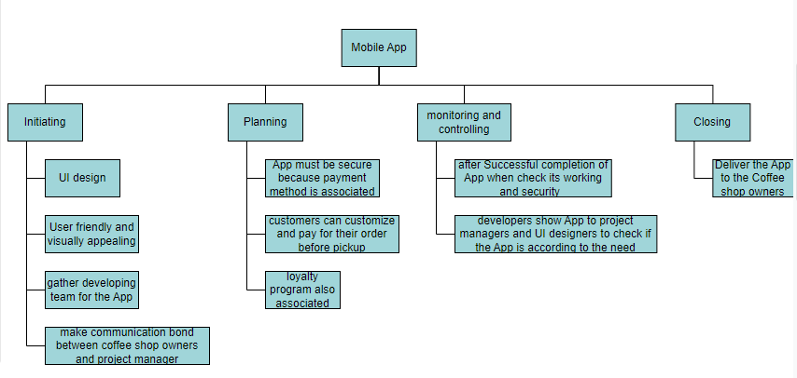

**Create a Project Schedule (Include start and end dates for each task)**

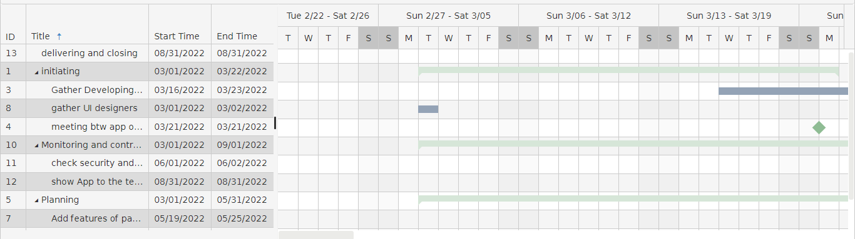

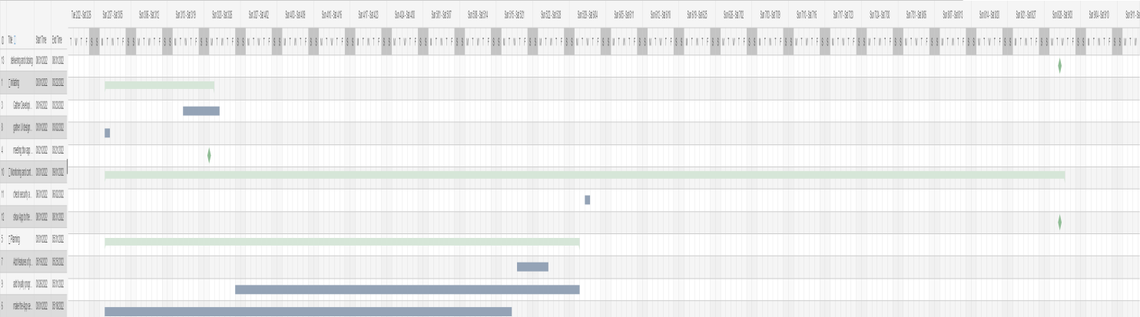

**Which Project Methodology(ies) would fit this project best.**

Agile methodology (Scrum) and critical chain project management (CCPM), would fit in this project because for the better completion of this project team needs meetings on weekly basis and scrum and CCPM suits best for software development and for the development of the company for which the software is asscociated.